**Games 101 – Critical Play Report – Association Football (Soccer)**

Composer: Gordon (Cunbo Li)

Email: [gordon.lee@nyu.edu](mailto:gordon.lee@nyu.edu) or [cl3846@nyu.edu](mailto:cl3846@nyu.edu)

Association Football or Soccer is one of the most popular sports in the world. Fans are attracted by Soccer with its performance, strategies, simple rules, availabilities and players’ personal skills. If we mention athletes of Soccer, the first superstar that comes to my mind is Ronaldo Luiz Nazario De Lima, because of his advanced skills in dribbling and shooting.

Dribbling is the most significant technical skill to a soccer player, which means a player should control the ball for changing direction, increasing and decreasing speed and breaking through defenders (the opponent team players). Ronaldo is a great player who has strongly capable of providing assists to his teammates, but he is more skillful and prefers beating several opponent’s players individually with dribbling and speed. For example, Figure01 to Figure03 is showing a real game of Ronaldo (in Blue team) dribbling and breaking through opponent’s defenders (Red team). Ronaldo took the ball as Figure01. Opponent’s player5 was trying to stop him. Opponent’s player4 was reinforcing player5 and as well as opponent’s player3. As Figure02, Ronaldo was facing to 3 opponent’s defenders. As Figure03, Ronaldo broke through player3, player4, and player5 in zigzag dribbling and then directly to a goal. “I love to score goals after passing all the defenders as well as the keeper. This is not my specialty but my habit”, Ronaldo has said. His capability in dribbling and speed is well-known in the world and soccer history. He is proud of Brazil and also a hero in every soccer fan’s heart.

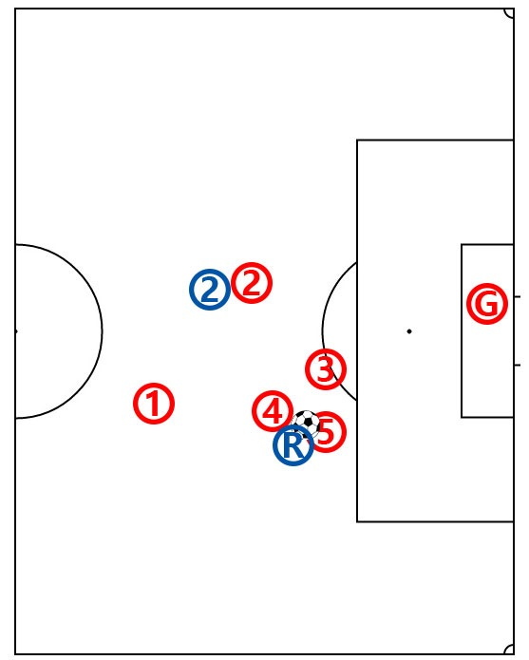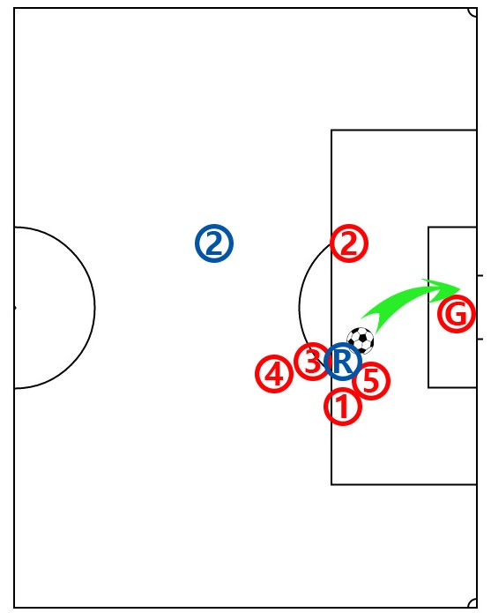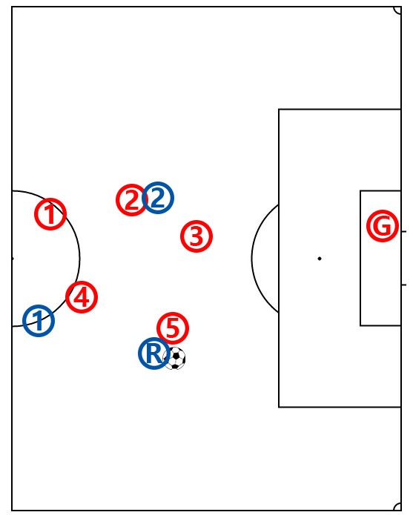

Figure01

Figure02

Figure03

Besides dribbling, shooting is also very valuable to be a skillful soccer player. That is to say, a soccer player should always have the consciousness to use every possible chance to shoot for a goal at appropriate time and place. Cooperation among in team members and planned strategy will increase chances for a player to make a goal shoot. Another instance about Ronaldo as Figure04 to Figure06 shown. This was a goal shot on World Cup Qualifier Match, October 12th, 2005. Brazil team was marked in Blue and Venezuela in Red. Brazil player1 passed the ball from midfield to goal area, as Figure04 shown. Brazil player2 catch the ball. Venezuela player6 and player7 came to defend and tried to stop Brazil player2, but Brazil player2 suddenly passed the ball to Ronaldo with his left foot, as Figure05 shown. Venezuela player6 paid too much attention to Brazil player2 but ignored Ronaldo. In Figure06, Ronaldo caught the ball and then shoot for goal. Ronaldo used the chance from his team-mate’s assist and appropriate place to break through the defense from Venezuela player6 and goalkeeper, and then finally got a goal. This is another point why Ronaldo is one of the famous soccer players in the world. His skills, consciousness, agility, decision always let Ronaldo know and make a chance to shoot for a goal.

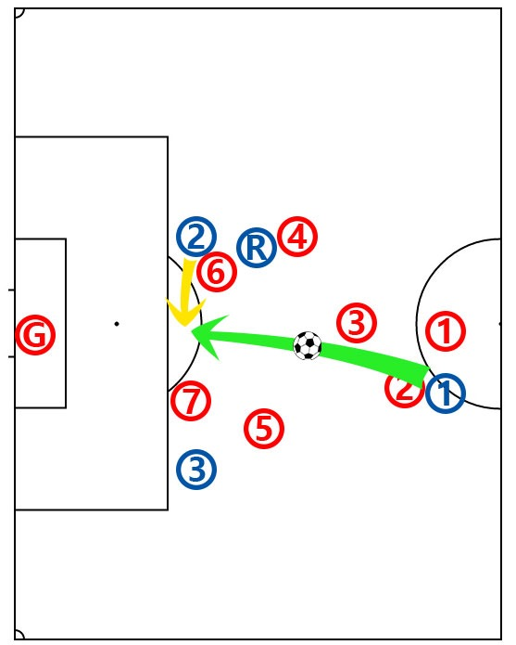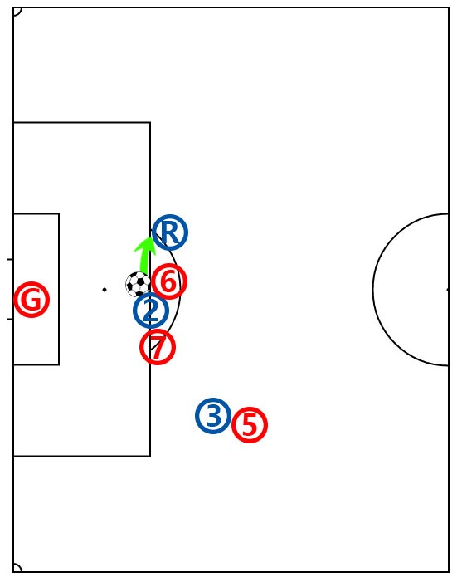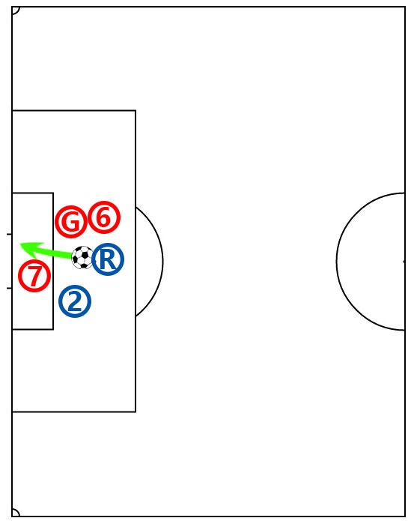

Figure04

Figure05

Figure06

Based on what we’ve discussed above, it is easy to make a conclusion that Ronaldo has amazing skills in dribbling and always know when and where to break through and shoot for a goal. So that Ronaldo has become to one of the most famous soccer players in soccer history and in people’s mind.